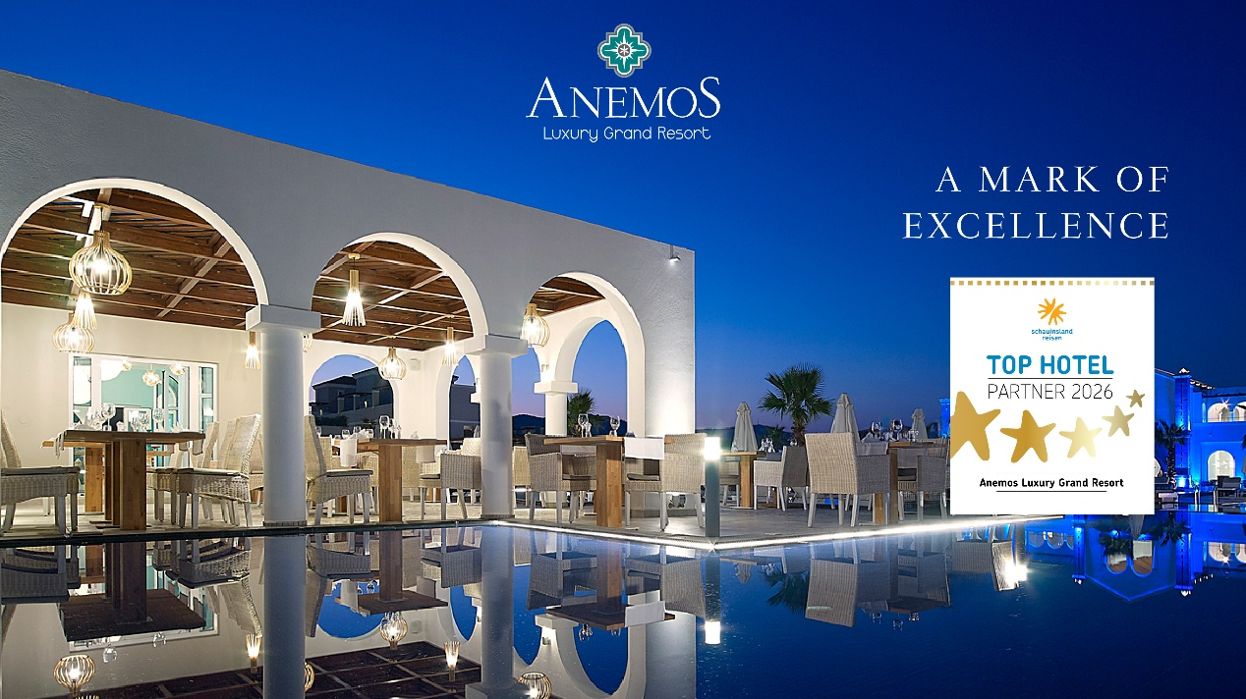
Anemos Luxury Grand Resort Receives Schauinsland Reisen Top Hotel 2026 Distinction
Anemos Luxury Grand Resort is proud to announce its recognition as a Schauinsland Reisen Top Hotel 2026, a prestigious award granted to properties that consistently achieve outstanding guest satisfaction and service excellence.
This distinction reflects the resort’s ongoing commitment to delivering high-quality hospitality, where attention to detail, personalized service, and premium facilities come together to create an exceptional guest experience. The award is based on authentic guest feedback, highlighting the trust and appreciation of travelers who choose Anemos Luxury Grand Resort for their stay.
Set in an idyllic location on Kournas Beach, the resort offers a refined blend of luxury, comfort, and authentic Cretan charm, making it a preferred destination for discerning travelers.
The entire team extends its sincere thanks to its valued guests for their continued support and remains dedicated to upholding the highest standards of service in the future.

